The Kimberley School
Candidate Exam Handbook

2023/2024

This handbook is reviewed and updated annually
Produced / reviewed by
Catrina Gillborn (Examinations Officer)
Date of next review | Sept 2024

Table of Contents
Introduction 8
Purpose of the candidate exam handbook 8
Malpractice 8
Personal data 9
Copyright 10
Coursework assessments/non-examination assessments (NEA) 10
Written timetabled exams 10
Contingency day - Summer 2023 11
On-screen tests 11
What to do if you identify you have two or more exam papers timetabled at the same time 12
Where you will take your exams 12
What time your exams will start and finish 12
Supervision during your exams 12
Exam room conditions 13
Where you will sit in the exam room 13
How your identity is confirmed in the exam room 13
What equipment you need to bring to your exams 13
Using calculators 14
What you should NOT bring into the exam room 14
Food and drink in exam rooms 14
What you should wear for your exams 15
Where your personal belongings will be stored during your exam 15
What to do if you arrive late for an exam 15
What to do if you are unwell on the day of an exam 15
What happens if you have an unauthorised absence from an exam 15
What happens in the event of an emergency in the exam room? 16
Candidates with access arrangements 16
Results 16
Post-results services 16
Certificates 17
Complaints and appeals procedure 18

JCQ unauthorised items poster
JCQ Warning to Candidates poster

Introduction
The Kimberley school appreciates that public examinations can be a stressful time for you and your family. We believe that it is important that those involved are as well informed as possible. Therefore, the rules and regulations stated within this handbook are designed to ensure fairness and minimise disturbance, so that all exams can run smoothly.
The aim of this guide is to help you get through the examination period, by explaining the
procedures that are put in place at The Kimberley School and by answering some of the questions you may have. Our School is committed to ensuring that all candidates and parents are fully briefed on the following important regulations:

Purpose of the candidate exam handbook
- To ensure candidates are provided with all relevant information about their exams and assessments in advance of them taking place.
- To inform candidates about malpractice in examinations and assessments.
- To inform candidates about the use of their personal data and copyright.
- To ensure copies of relevant JCQ information for candidate documents and exam room posters are provided in advance of any exams and assessment being given.
- To answer any questions candidates may have.
- To signpost candidates and parents/guardians to any exam-related policies and procedures.

Malpractice
What is malpractice? Malpractice means any act or practise which is in breach of the Regulations of the set exams requirements.
At The Kimberley School, we take incidents of malpractice very seriously! Any acts of Malpractice will be reported to the relevant awarding bodies, which could result in the candidate being disqualified from their exam, regardless of whether the paper has been completed or not.
In order to prevent any acts of malpractice taking place at The Kimberley school we aim to ensure that we maintain the integrity of the qualifications and that strict regulations are put in place.

The JCQ online portal provides greater depth information regarding what constitutes as malpractice, such as:
  - Introduction of unauthorised material into the examination room
  - Breaches of examination conditions
  - Exchanging, obtaining, receiving or passing on information which could be examination related (or the attempt to)
  - Offences relating to the content of candidates’ work
  - Undermining the integrity of examinations/assessments
During examination times if there is evidence of malpractice within the exam room it will be dealt with by the Invigilators and the Exams Officer. In cases of minor behaviour problems within an exam a warning will initially be given to the candidate to stop. If the behaviour persists or if there is a more serious malpractice incident, such as the possession of a mobile phone in the exam room or a media device, immediate action will be taken by the Exams Officer.
We advise that you take this information very seriously, as it could result in an instant disqualification.
Ask yourself… Is it worth it!

Personal data
The delivery of examinations and assessments involve centres and awarding bodies processing a significant amount of personal data. It is important that both the centres and the awarding bodies comply with the requirements of the General Data Protection Regulation and the Data Protection Act 2018.
With this in mind, candidates at the Kimberley School are advised to read the JCQ document
“Information for candidates – Privacy Notice, General and Vocational Qualifications”

At the time when candidate’s GCSE and GCE entries are being submitted to the relevant awarding bodies, candidates will be given the “information for candidates” document, as stated above.
The Head of Centre or a member of the Senior Leadership Team will advise any persons involved in administering, teaching or completing examinations and assessments, that where malpractice is suspected, personal data about them will be provided to the relevant awarding body. Personal data about them may also be shared with other awarding bodies, the qualifications regulator or professional bodies, in accordance with the JCQ publication.
Please also refer to “The Kimberley Schools Exams Archiving Policy 2023/24” For further information.

Copyright
- The copyright of any form of work created by a candidate that is submitted to an awarding body for assessment (referred to as Assessment Materials) belongs to the candidate.
- By submitting this work, a candidate is granting the awarding body a non-exclusive, royalty-free licence to use their assessment materials (referred to as Assessment Licence).
- If a candidate wishes to terminate the awarding body’s rights for anything other than assessing his/her work, the awarding body must be notified by the centre and it is at the discretion of the awarding body whether or not to terminate such rights.

Please refer to the Generals Regulation section 6

Coursework assessments/non-examination assessments (NEA)
Some of the subjects you are studying may have an element of coursework or controlled assessment included within them that have to be completed, marked and internally
moderated. The marks and work needs to be sent to the Awarding Bodies (Examination Boards) prior to the formal examination sessions take place. The Kimberley school sets strict deadlines, which cannot be changed to allow time for this process to be completed and to meet the board deadlines.

Coursework entry assessment deadline – 15th May 2024
Students who do not submit coursework on time will not be allocated a mark for this portion of their exam and their overall grade will be affected. They may also not be eligible for
special consideration for the formal exams, should they be ill, as they will not have
completed the minimum requirements of the course.
The Kimberley School is committed to ensuring that our staff mark students’ controlled assessment/coursework fairly, consistently and in accordance with the awarding bodies’ specifications and subject-specific associated documents.
If you feel that this may not have happened in relation to your work, you may file an appeal.
Please note that an appeal may only be made against the assessment process and not against the mark submitted to the awarding body.
After the candidates’ work has been internally assessed, it is moderated by the awarding body to
ensure consistency in marking between centres. The moderation process may lead to mark changes. This process is outside of the control of The Kimberley School and is not covered by this procedure.

Written timetabled exams
Written exams are the more traditional method of assessment for attainment. Candidates participating in these courses are issued with timetables at the start of the Summer term for the Summer Series and at the end of September for the November (resit) series. When you have been given your candidate statement of entry, please check that the information within it is correct. If you think it is incorrect, such as you have been entered for an exam you shouldn’t be sitting or you identify an exam clash, then please see your Exams Officer – Mrs Gillborn or your Form Tutor as soon as possible, so that this error can be rectified.
Please read the JCQ documents in the Appendices of this handbook for greater detail with regards to written timetabled exams expectations and supporting coursework requirements.

Contingency day - Summer 2024
The designation of a ‘contingency day’ within the common examination timetable is to assist in the event of a national or local disruption to examinations. Such as, an emergency school closure or a compromised paper. It is a part of the awarding bodies’ standard contingency planning for examinations and therefore we advise parents to be aware that if the contingency date is used, your child may have an exam moved to this day and so care should be taken before making arrangements, such as booking holidays after the GCSE’s. This year, the awarding bodies have designated Thursday, 6th June PM, Thursday, 13th June PM & Wednesday, 26th June 2024 as ‘contingency days’ for examinations.

On-screen tests
On screen tests are conducted and invigilated under the same exam conditions as our written examinations.
Candidates CAN NOT use pre-prepared templates, have access to the internet, emails, data stored on hard drives or data from portable storage media i.e. memory sticks or floppy disks. Candidates will also be asked to remove ALL types of watches, turn off mobile phones and store them away in their bags, outside of the exam room.
Candidates are reminded that the possession of any unauthorised material can result in possible disqualification. (As stated in the JCQ information for candidates document– on-screen tests 2023-2024).
“Warning to candidate” posters are displayed at the entry of the exam room. These rules are then verbally reiterated to the candidates before the exam begins. Copies of these posters can be found in the Appendices of this handbook.

What to do if you identify you have two or more exam papers timetabled at the same time
If you have two exams timetabled at the same time and they total less than three hours in duration, you will sit one exam after the other.
Where they are more than three hours in length, you will sit one exam in the morning (usually the longer duration) and one exam in the afternoon (usually the shorter duration). Please be mindful that you will be supervised at all times in between the two exams, including lunchtime and breaks.

Clash exams: If you find an exam has been timetabled differently from your peers this is because you have a clash of more than 3 hours and one exam has been moved. If you have any questions about your exams, please speak to the Exams Officer – Mrs Gillborn.

Where you will take your exams
The majority of the Exams will take place in the school’s main Halls. However, extra rooms are provided for students who require additional support, which is referred to as an “Access arrangement”. All of the allocated exam rooms are indicated on individual candidate timetables, to ensure that all students know exactly where to go on the day of their exam.

What time your exams will start and finish
- Exam and assessments generally start at 9:00 (AM) and 13:00 (PM)
- Students are expected to remain in the examination venue for the full time of the exam or assessment.

On some occasions your exam may finish earlier than another exam being held in the same room. If this is the case you must not disturb any other students who are still taking an exam. When your exam finishes you are to leave the exam room in an orderly manner.

Supervision during your exams
At The Kimberley School, during all exams, candidates are supervised by a team of invigilators. If a candidate has been granted an additional 1-2-1 access requirement, then they will be supported by an individual invigilator. All of our invigilators have undertaken full “Exams Office” training and are under strict instructions to follow rules and regulations when conducting exams, as directed by the JCQ and awarding bodies. If a candidate believes that these rules were not adhered to by the invigilators, they need to then take their concerns and report them to the Exams Officer - Mrs Gillborn, immediately after the exam.

Exam room conditions
The night before the exam it is good practice to check and reconfirm the start time, venue and seat number for the assessment.
Students are advised to arrive at school at least 30 minutes before the schedules start of their exam.
A seating plan will be displayed outside of the venues – Main Hall only.
Candidates will be invited into the room once the invigilation team are ready. Students should enter the room in silence under exam conditions and will remain this way until given permission to leave.
Candidates must listen and follow all instructions given by invigilators.
Candidates must not communicate with or disturb other candidates.
In the exam room the following will be displayed – Centre Number, Subject Title, Paper Reference Number, actual starting & finishing times and date of each exam.
Any relevant information relating to the completion of the front of answer books (legal first name and surname that matches the entry information, candidate number). This information should not be completed until instructed to do so by the invigilator.
Candidates must not open the question paper until the official start of the exam.

Where you will sit in the exam room
At the Kimberley School candidates sit in the Halls and in the Community room in “Exam number” order. When candidates enter the Halls they are advised to sit at the desk which has their photo ID on it. Invigilators who are located within the Halls are there to support and direct anyone who cannot find their place. Where candidates have been granted extra time, they will sit to the far side of the halls, in order to prevent them from being disturbed when the other candidates leave. Candidates who have special access arrangements, sit at the desk provided for them, in the allocated 1-2-1 room.

How your identity is confirmed in the exam room
The JCQ regulations state that invigilators must establish the identity of all candidates sitting the examinations, whether in the halls or in additional rooms. The Head of Centre must make sure that appropriate arrangements are put into place so that all invigilators can carry out adequate checks on the identity of all candidates. As mentioned previously, candidates are allocated photo ID cards during the exams period and spot checks to ensure that correct candidates are sat at the correct desk are carried out at the start of each exam. If a candidate sits an exam in another candidate’s name, then that is classed as malpractice and that candidate will be disqualified, so it is imperative that all candidates check that they are sat at the correct desk, with the correct ID. Where it is impossible to identify a candidate, due to the wearing of religious clothing, such as a veil, the candidate will be approached by a member of staff who is the same gender and taken to a private room where they will be politely asked to remove the religious clothing for identification purposes. The exams officer will inform the candidates of this procedure in advance of the exam. An attendance register is also taken at the start of the exam to confirm identity and attendance.

What equipment you need to bring to your exams
Please bring your own equipment and ensure that it meets the criteria set out by the JCQ regulations i.e black pen, pencil, pencil sharpener, ruler, and highlighter pens. All equipment must be in a clear see through pencil case. If you forget or cannot access your own equipment, please inform the invigilators and they will provide you with a spare school set.
Candidates are reminded that during exams times, only official examination stationery can be used, no other stationery, including scrap paper or post it notes for rough work, can be provided.
In the examination room candidates must not have access to items other than those stated in the instructions on the question paper, the stationery list or the specification for that subject. If candidates are found to have any unauthorised material in an examination, whether or not they intend to use it, this will be deemed as malpractice and the candidate will be reported to the relevant awarding body.

Using calculators
- You must be aware of the JCQ awarding body instructions regarding the use of calculators in your exams.
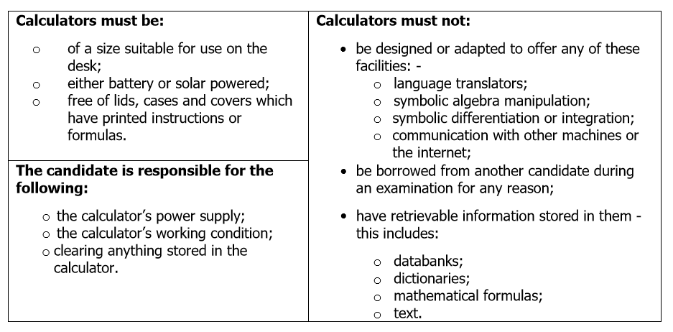
The above table has been taken from the JCQ Instructions for conducting examinations 2023-2024, please follow the link if you have any queries regarding the above information.

What you should NOT bring into the exam room
Candidates are aware that the following items cannot be taken into an exam and if found within the exam room, will be treated as a case of malpractice.
Items not to be taken into the exams room:
- No watches are to be taken into the exams room. All watches must be removed and placed outside of the exams room.
- No mobile phones or electronic devices can be taken into the exams room. This includes iPods! Candidates cannot listen to music whilst sitting their exams. This is classed as malpractice and will result in disqualification.
- No Airpods, earbuds/earphones can be taken into the exam room.
- No food or labelled drinks. Only drinks in a clear bottle, with no labels are allowed into the exams rooms. Please be smart and remove the label before you enter the exams room. If you have a drink in a bottle which is not clear, then the drink will be taken off you.
- Any pre-written notes, scrap paper, or jotters.

Food and drink in exam rooms
At the Kimberley School, we do not permit candidates to take food into the exams rooms. If a candidate has specific dietary requirements i.e diabetes, then special access arrangements will be made in advance to help support these candidates during exam times. Candidates are allowed to take a drink with them into the exams room. However, the drink must be in a clear bottle, with all labels removed. Please see JCQ regulations ICE P18 for further information.

What you should wear for your exams
All students MUST be in full school uniform, including black shoes. Rules on jewellery still apply. Failure to comply could prevent students being allowed to sit their examination.

Where your personal belongings will be stored during your exam
At the Kimberley School we advise all candidates to turn off their mobile phones and store them in their bags. All personal belongings are stored outside of the exams rooms. Candidates will not have access to their personal belongings during exam times. This rule also applies to any form of media device.

What to do if you arrive late for an exam
If you arrive within one hour of the national official start time of the exam, you may still be allowed to take the exam. This it entirely at the discretion of the centre and it is the Exams Officer who will determine if this can be allowed. If a candidate has arrived late and has been allowed to sit the exam, then the full allocated time for the exam will be given.
A candidate will be considered very late if they arrive more than one hour after the awarding bodies starting time. If the centre allows the student to sit the exam, then the awarding body must be informed of the situation as to why the candidate is so late. The awarding body will make the decision whether to accept the paper or not, based on the information proved. If the awarding body decides to not accept the paper, then unfortunately the candidate will be disqualified. Please refer to the JCQ ICE booklet P21 for further information.

What to do if you are unwell on the day of an exam
If you are Ill, you should always try to sit the exam no matter how unwell you are feeling. Unless your Illness is contagious or you have a severe stomach upset, If you turn up for an exam and are unwell, then your parents or carer should write a letter to the Exams Officer, Mrs Gillborn, explaining the circumstances, in order for special consideration to be applied for. If you are too Ill to sit the exam on the day, then your parents or carers must telephone the school before 8.45am to record your non-attendance.
You should then provide a doctor’s note to cover this absence, so that special consideration can be applied for.

What happens if you have an unauthorised absence from an exam
You can only take an exam at the set date and time, so if you forget to come in to school then you will have missed the exam.
Dates for external exams are fixed by the Awarding Bodies and are subject to change until close to the time that students start examination leave.
Parents are reminded that they require the Head teacher’s permission to take students out of school (for exceptional circumstances only) and that they book holidays during term time at their own risk. It is strongly against good practice, careful preparation and school policy to take student holidays in term time. Any holiday leave will be recorded as absence, which will then result in the involvement of the Pastoral Office.
Please be aware that You will be charged for any exam that you have been entered for but do not attend, due to any reason other than severe illness which is verified by a doctor’s letter. Please refer to JCQ ICE P22 for further information

What happens in the event of an emergency in the exam room?
If the fire alarm does sound during an exam, you will be asked to stop writing, put down your pen, close your exam paper, sit in silence and wait for instructions. If the fire alarm is genuine, you will be asked to leave everything exactly where it is (including your exam papers) and you will be led to the fire evacuation assembly point in an orderly manner. Remember that you will still be under exam conditions and should not communicate in any way with other students. The length of time of the disruption will be noted by the Invigilator and you will be given that time at the end of the exam.

You must remember that you are still under exam conditions, and under no circumstances should you talk to one another. During an evacuation you must leave all of your belongings and under no circumstances can you use your mobile phone during this time.

Candidates with access arrangements
In exceptional circumstances, The Kimberley School can apply to the Awarding Bodies to ask for special consideration, for students who attended their exam but were disadvantaged or were absent from the exam due to illness. Special Consideration is a post-examination adjustment to a candidate's mark or grade to reflect temporary injury, illness or other indisposition at the time of the examination/assessment. The decision whether Special Consideration will be applied to you will be made solely by the examination boards and we cannot guarantee that this will always be awarded.

Results
Getting your results can be both exciting and nerve‐racking. The best piece of advice anyone can offer is to stay calm. If you don't get the results you were expecting and your grades are higher or lower than predicted, there are lots of
options available. If you have any questions on results date, the Kimberley School staff will be on hand on Results Day to offer any help, advice and support.

GCE Results Day 15 August 2024
GCSE Results Day 22 August 2024
Please note ‐ Results will not be given over the telephone or by email and will only be given to other people by prior arrangement. Please note, these rules may change if school is closed due to measures beyond our control. (see school contingency plan for greater detail).
Alternatively, if someone is collecting your results on your behalf they must have a letter, signed by yourself, giving them permission to collect your results. As well as a form of ID to prove who they are. Please be mindful that we are unable to release results to anyone without written permission from you, even if it is a parent.

Post-results services
If you have received your results, but find that you are unhappy with one of the grades you have been awarded by the Exam Boards, you can speak to a member of the “Exams Office” to see if it is appropriate to submit an enquiry about Results to the relevant Exam Board regarding your grade. The following procedures will apply to this process:

- All requests for enquiries about results must be received by the Exams Officer in school, no later than 21 days after the publication of provisional results to allow time for processing the request.

- No request can be actioned before the Exams Office receives a fully completed JCQ Candidate Consent Form, signed and dated by the candidate. The form must be fully completed and signed by the student.

- The relevant Head of Department will then complete a ‘Request for Enquiries about Results [EaR]’ form outlining the student’s details, all exam units concerned, and which Ear Service is required. This form must be signed and dated by the Head of Department prior to submission to the Exams Office. Candidates need to be aware before they sign the form that the final subject grade they are awarded following an enquiry may be higher or lower than the original grade they were given.

- Where a student wishes to make an enquiry about exam results, they should discuss it with the appropriate Head of Department in the first instance. If they agree to the enquiry, then the school will fund the enquiry about results.

- If the Head of Department disagrees that there is a valid case for an enquiry but agrees that the student can go ahead with the enquiry, then the student must pay the appropriate fee for the enquiry. The fee must be paid on ParentPay.

- The school will inform the pupil as soon as possible about the outcome of any enquiry about the outcome of any Enquiry about Results. Note results can go down as well as up.

Certificates
Exam boards do not issue official certificates to schools until the month of November. Meaning that candidates cannot collect them until this time. Candidates will receive a letter in the post from the school’s Exams Officer, informing them that their certificate has arrived and is ready to be collected. All certificates must be collected in person. If you wish for your certificate to be collected by someone other than yourself, you must provide them with a signed letter giving them permission to collect your certificate on your behalf. The person collecting on your behalf must also bring a form of ID to prove who they are.
Certificates will not be posted out to candidates, they must be collected from the school’s Exams Officer - Mrs Gillborn.
Certificates are stored securely within the school for one year. After that, Certificates will be destroyed and an electronic copy will be kept on file for four years. After four years’ certificates will be deleted, due to GDPR regulations. Please be aware that certificates after this time will need to be obtained from the relevant awarding bodies and these will come at a significant cost.
We strongly advise that you collect your certificates on time and store them safely at home.

Complaints and appeals procedure
If a candidate (or his/her parent/carer) has a general concern or complaint about the centre’s delivery or administration of a qualification he/she is following, The Kimberley School encourages him/her to try to resolve this informally in the first instance. A concern or complaint should be made in person or by telephone to the Exams Officer (Mrs Gillborn) or Head Teacher (Mr Park).
If a complaint fails to be resolved informally, the candidate (or his/her parent/carer) is then at liberty to make a formal complaint.
How to make a formal complaint:
- A complaint should be submitted in writing by completing a complaints and appeals form.
- Forms are available from schools’ website or from the exams office
- Completed forms should be returned to Mrs Gillborn - Exams Officer
- Forms received will be logged by the centre and acknowledged within 3 working days
How a formal complaint is investigated:
- The Head of Centre will further investigate or appoint a member of the Senior Leadership Team (who is not involved in the grounds for complaint and has no personal interest in the outcome) to investigate the complaint and report on the findings and conclusion
- The findings and conclusion will be provided to the complainant within 2 working weeks
Appeals:
Following the outcome, if the complainant remains dissatisfied and believes there are clear grounds, an appeal can be submitted.
- Any appeal must be submitted in writing to the Head Teacher by completing a complaints and appeals form
- Forms received will be logged by the centre and acknowledged within 3 calendar days
- The appeal will be referred to the Chair of Governors (or a special Committee of the Governing body) for consideration
- The Chair of Governors (or Committee) will inform the appellant of the final conclusion in due course.
Effective from September 1st 2021

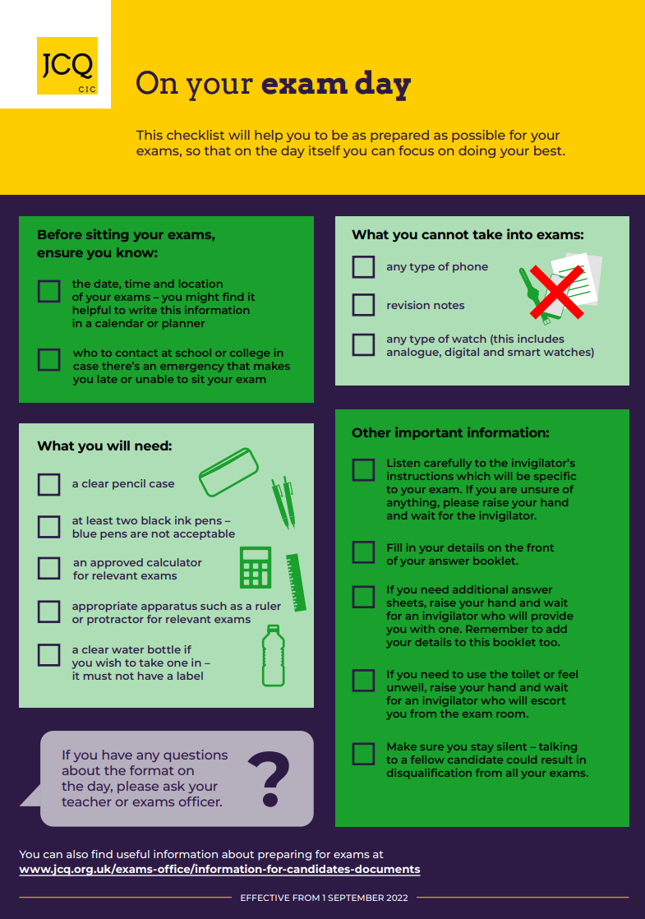

JCQ unauthorised items poster

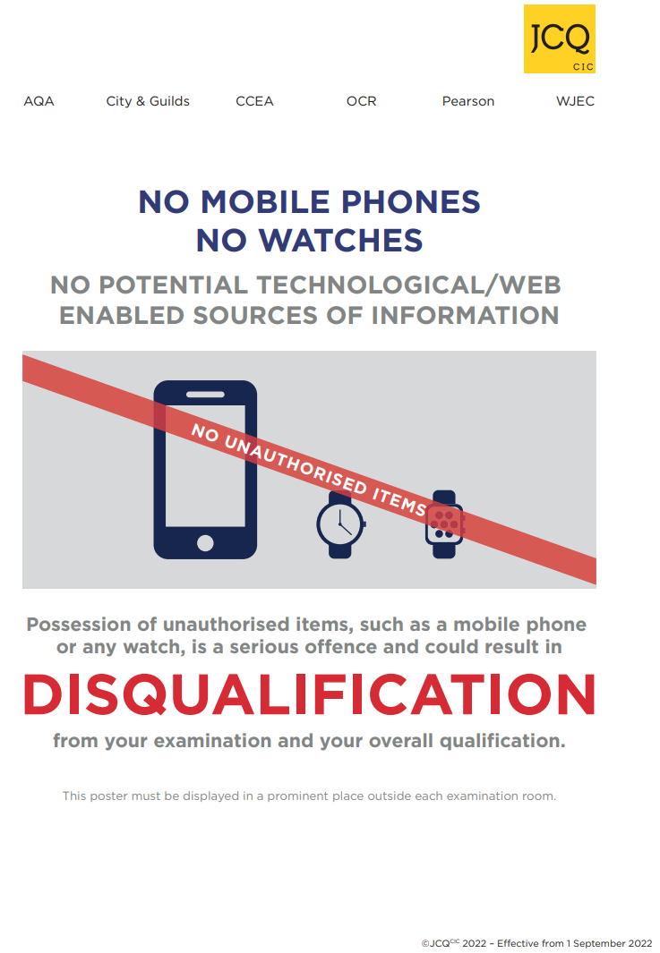

JCQ Warning to Candidates poster

